**Daily Scrum or Standup Meeting**

Team name: Team 08

Scrum Master: Zion Steiner

Date: Nov 15

|  |  |  |  |
| --- | --- | --- | --- |
| **Team Member** | **What did you do since the last Scrum?** | **What do you plan to do before the next scrum?** | **What obstacles do you have?** |
| Hannah Howell | * Did 8 hours of grading for CS 1 | * I’m finally caught up on grading, so this weekend, I’ll crunch down on this project * Little Tweaks issue | * Other homework, grading, HackUSU * Still have a sick husband * Technical Presentation |
| Garrett Johnson | * Worked on other projects | * I finished another project, so I will be able to start on auction publishing and QR codes this weekend | * Presentation to work on * Possibly Hackathon |
| Zion Steiner | * Finished view winners page, except for unit tests | * Finish unit tests on view winners page | * Other homework |
| Tristan Thomas | * Finished recent bid deletion, which auto updates all values. * Displayed if bidder is currently winning an item. * Admin can’t edit current price now. * Admin can only edit starting price if the item is not yet open for bidding, or if there hasn’t been any bids on the item. | * Handle multiple bids on the same item at the same time. * Handle a recent bid being deleted at the same time that a new bid is placed. | * Technical presentation * Advanced algorithm homework * Linear algebra homework * Operating systems program to write |
| N/A |  |  |  |

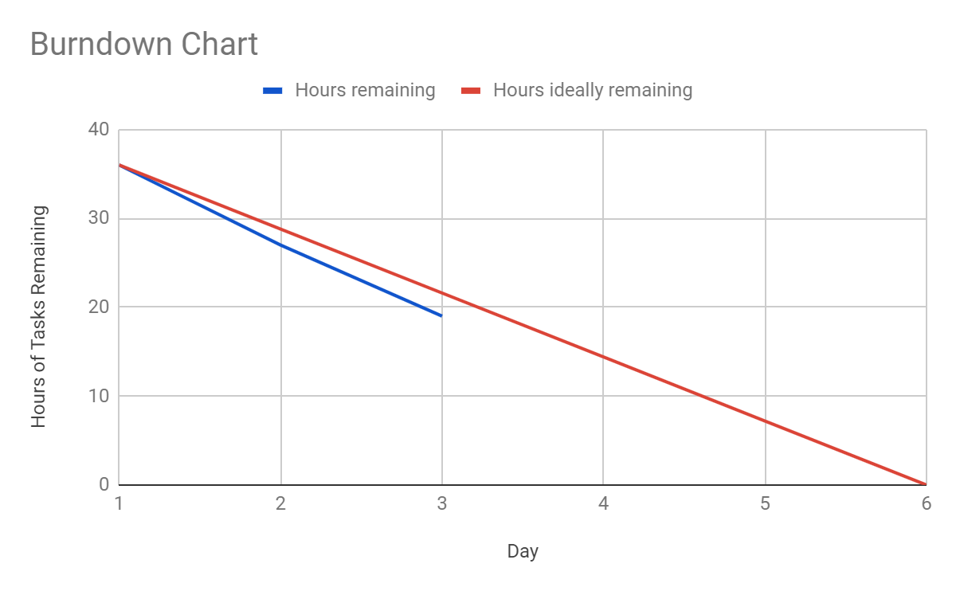

# Screenshot of your project board

